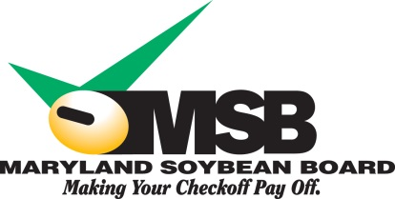

Green Ribbon Fairs
A Program from the Maryland Soybean Board

Maryland’s fairs and agricultural expos have a rich history of showcasing agriculture. Now, it’s possible to support and celebrate the products that today’s agriculture brings to market at your fair, thanks to the Green Ribbon Fairs program.
The Maryland Soybean Board is seeking one or more Maryland fairs to demonstrate the benefits of soy-based products such as biodiesel, cleaning supplies, and/or building materials.
The Maryland Soybean Board is supported by the soybean checkoff, a national program funded and directed by U.S. soybean farmers. As part of their mission to promote and ensure the quality of U.S. soybeans, the soybean checkoff has invested in the development of soy as an alternative to increasingly costly and less environmentally friendly ingredients. Through a variety of research and promotion programs, the soybean checkoff has been able to support the creation of hundreds of soy-based products over the past two decades.
Through a competitive application process, the soybean checkoff may provide a total of $18,000 in reimbursement funds to one or more fairs that use soy-based products. Fair managers should complete the attached application, including a plan to integrate soy-based products into daily operations, fair activities and/or improvement projects. Fairs are encouraged to apply for funding between $3,000 and $5,000, although larger requests will be considered. MSB’s Communications Committee will award reimbursement funds to fairs that propose the best ways to help demonstrate soy-products to farmers and fairgoers.
The deadline to apply is January 16, 2017. Fairs will be notified on or before February 3, 2017.
Please note that this is a reimbursement program and not a grant. Selected fairs will receive reimbursement funds for soy products after purchase by submitting invoices and accompanying support documents to MSB. Only the cost of the soy-based product(s) is eligible for reimbursement. Reimbursement funds will be processed within 30 days from the date the reimbursement request is received. Fairs selected to participate will be required to review and sign a Reimbursement Partnership Program and Project Agreement. All projects must be completed prior to September 30, 2017, and requests for reimbursement and supporting documentation received prior to October 10, 2017.

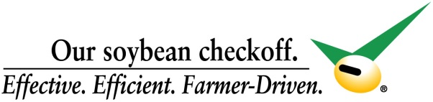
Green Ribbon Fair Application
Please type or print clearly; submit to Sandy Davis by January 16, 2017 via email at sdavis26@verizon.net or to P.O. Box 319, Salisbury, Md. 21803. Fairs that are selected to participate will be notified by February 3.

Fair:
Fair Manager:
Phone Number:
Address:
City/State/Zip:
E-mail Address:
Dates of Fair:
Estimated Attendance:
Please provide a written response to the following questions:
1. How will your fair use these reimbursement funds?
2. How will your fair help the soybean checkoff promote soy-based products?
3. Budget breakdown, including total project cost, requested funding from MSB and any other funding sources:
4. How does your fair help promote agriculture?
5. What green products does your fair currently use?
6. How will you promote this project in your community?
7. Timeline for this project:
Soy-based solutions
Your proposal should include a plan to integrate soy-based products into daily operations, fair activities and/or improvement projects. Reimbursement funds will be awarded to fairs that can best demonstrate the benefits of soy to fairgoers:
Better performance – From delivering increased lubricity in diesel fuel to creating nontoxic cleaners tough enough to handle the biggest messes, soy has the strength and the flexibility to help a number of products outperform their petroleum-based alternatives.
Environmental benefits – As a fully renewable and biodegradable resource, soy offers a natural alternative to petrochemicals that not only creates greener products but is also greener to produce.
A U.S.-grown alternative – By replacing the ingredient of foreign-produced petroleum with a crop grown in fields across America, U.S. soy is able to deliver sustainable products that benefit both our rural economies and our nation’s energy security.

Some soy products may be available for purchase at your local hardware or retail store. Others can be obtained directly from the manufacturers. Check company websites to locate products in your area. For a comprehensive list of soy-based products, including contact information, visit www.soybiobased.org

